12.79: a) From Eq. (12.14) with the mass of the sun,

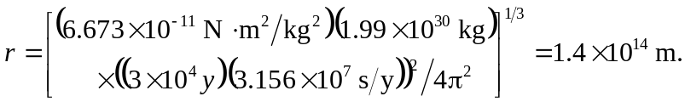

This is about 24 times the orbit radius of Pluto and about  of the way to Alpha Centauri.

